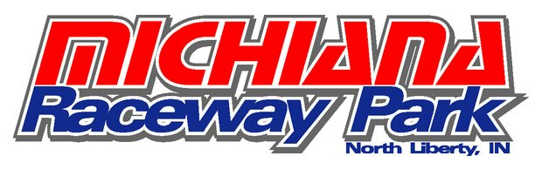

61870 Crumstown Hwy
North Liberty, IN 46554
Text (269) 720-9196
www.michianaracewaypark.com
Race Kart Pricing
instruction included
2 ten minute sessions 9 HP/60” $50
3 ten minute sessions 9 HP/60” $65
4 ten minute sessions with timing 9 HP/60” $80
Minimum of 2 drivers to book
Kart & All safety equipment included
Drivers need to be 14 and above and
60 inches tall to race 9.5 Honda
Hours 9-5 Eastern, Monday – Sunday
Appointment Required
Call /text (269 720 9196) TO BOOK
Email g.lobaugh@gmail.com

